SaaS Risk Analysis (Example)
Vendor Questionnaire:
https://www.cisa.gov/sites/default/files/publications/ICTSCRMTF_Vendor-SCRM-Template_508.pdf

SaaS Overview
Name:
Provider:
Description:
Risk Identification
Security Risks
- Data breaches
- Unauthorized access
- Insecure APIs
- Insufficient encryption
Compliance Risks
- Non-compliance with GDPR, HIPAA regulations
- Lack of data residency options
- Limited audit trails
Operational Risks
- Downtime and service interruptions
- Data loss or corruption
- Vendor lock-in
- Poor performance
Integration Risks
- Compatibility issues with existing systems
- Dependency on third-party integrations
- Data silos
Risk Assessment
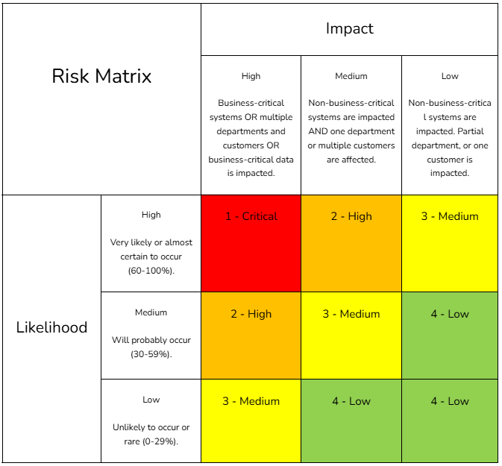
[Service] is high risk since it has high impact and medium likelihood. It has a very high impact of spilling customer data, including very sensitive PII such as social security numbers, or user credentials that the attacker can use to pivot into company systems. This data breach can occur through a SQL injection that requires some inside knowledge of how the database is organized. Thus, there is a medium level of likelihood that this event could occur.
Risk Mitigation Strategies
Security Measures
- Implement strong encryption protocols
- Enable multi-factor authentication
- Regularly audit access controls
Compliance Controls
- Review vendor compliance certifications
- Ensure contractual agreements address compliance requirements
- Monitor regulatory changes and updates
Operational Controls
- Implement backup and disaster recovery plans
- Monitor service uptime and performance
- Develop contingency plans for service disruptions
Integration Planning
- Conduct thorough testing of integrations
- Establish data mapping and normalization procedures
- Maintain clear communication with integration partners
Risk Monitoring and Review
- Monitor the service for security events, setting up alerts based on identified risks and saving logs.
- Update this document quarterly. Conduct risk assessments to identify new risks and evaluate the effectiveness of risk mitigation strategies, editing the plan if necessary.
Reporting and Communication
- Update documentation and present findings of risk assessment to senior management and stakeholders.
- Draft up a list of suggested revisions to the mitigation and disaster plan and present it to senior management, receiving feedback before solidifying and implementing changes.

